**Introduction**

In this document, we will show how to get started with MQX RTOS for Kinetis SDK. We will use Kinetis Design Studio with Processor Expert. Processor Expert provides a graphical interface for configuring your project and adding useful software components.

**Resources**

PC running Windows 7 with the following software:

• Kinetis Design Studio (KDS) v2.0.0

• MQX for KSDK v1.1.0

Hardware:

• FRDM-K64F

**Notes**

In the past, Processor Expert included MQX Lite and MQX components. With the release of the Kinetis SDK, there is a new MQX_KSDK component that is suitable for configuring the version of MQX RTOS that comes with the Kinetis SDK. Be sure to use the new component!

New Kinetis Design Studio projects enabled with Kinetis SDK and Processor Expert use an Operating System Abstraction (OSA) component which is used to select which RTOS (or no RTOS – baremetal) option you are using. The OSA component will inherit in the selected RTOS component for you. So, don’t add in MQX_KSDK yourself. Let the OSA do it.

1. **Create project with Processor Expert**
   1. Open KDS
   2. Set the workspace directory to **C:\mqx_ksdk_class** (or your choice of other new directory location) and click on OK.

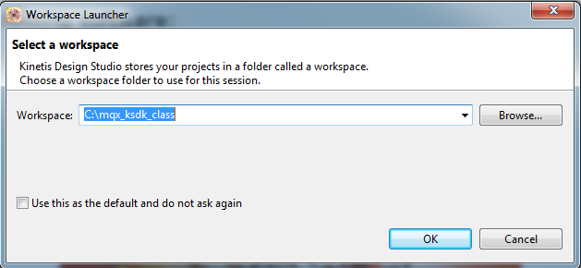

* 1. Click on the “Workbench” icon to go to the main Workbench screen. This only has to be done the first time a new workspace location is used.



* 1. Install updates. See section 5.2 in the Getting Started with Kinetis SDK guide.
  2. Create a New Kinetis Design Studio Project.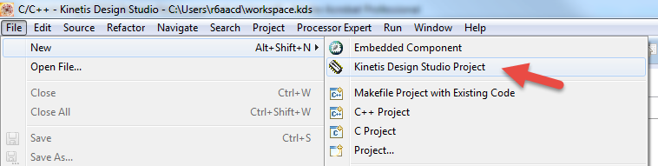
  3. Name it and click Next. 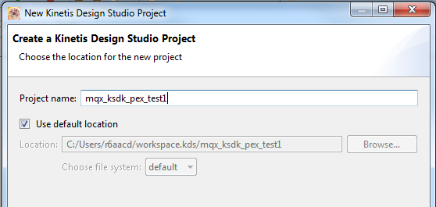
  4. Select a board or processor and click Next.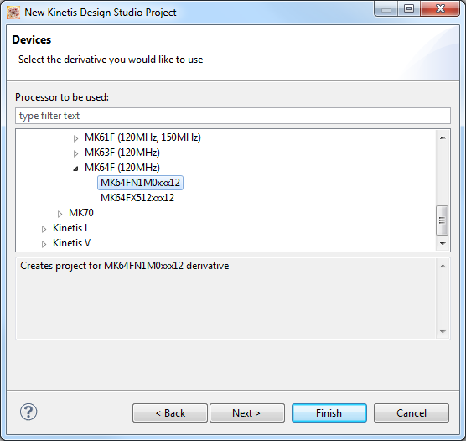
  5. Choose Kinetis SDK and Processor Expert and click Finish. 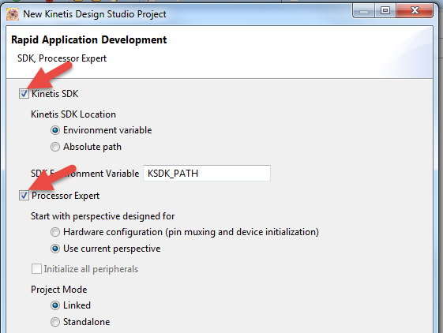

1. **Develop the project with Processor Expert**
   1. Now you have a new Kinetis SDK project that is ready to be configured with Processor Expert.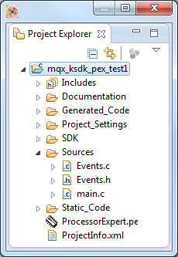
   2. In the **Components** window, under **Components**, open the OSA component. 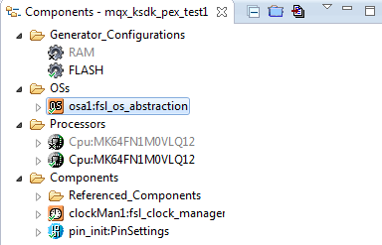
   3. The  **Component Inspector** window will now show you the Properties and Methods for that component. From the OS dropdown list, choose **MQX_KSDK** as your OS. 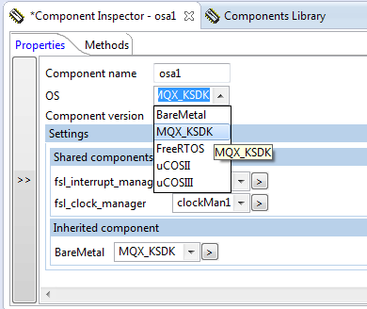
   4. Now you need to set up the MQX_KSDK component for use in your project. Open the MQX_KSDK component (inherited by the OSA component).  
      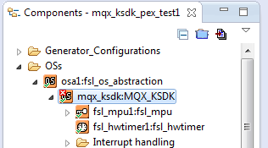
   5. Select the **Configuration parameters** tab.  
        
      In the **Configuration set**, you have the choice of **MQX Lite** and **MQX Standard**.   
        
      For this first example, I will choose MQX Lite. MQX Lite is a light weight configuration of MQX RTOS offering a subset of capabilities. MQX Lite uses static memory allocation by default. If you want to use the RTCS TCP/IP stack, MFS file system, dynamic memory allocation, or some of the advanced features of MQX RTOS, use MQX Standard.  
      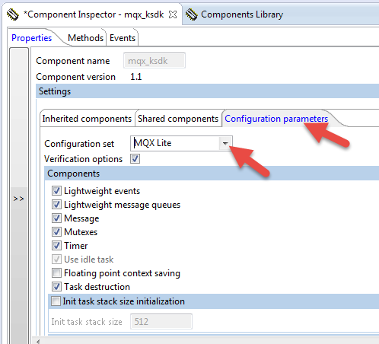
   6. Now select the **Shared components** tab. You can see that it uses the **DbgCs1** component for serial communications.  
      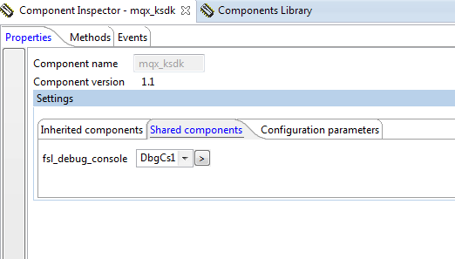
   7. Click on the **DbgCs1** component.  
      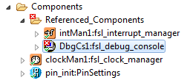  
      You need to tell it which UART should be used for the DbgCs1 component (default serial port).  
        
      For Device, choose UART0. Then pick a baud rate – I chose 115200. Then select the Pins to be used. This uses the net names for the signals on the schematic.  
        
      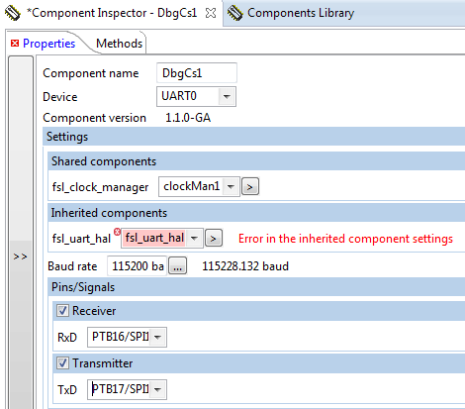
   8. Click on the arrow next to **fsl­_uart_hal**.  
        
      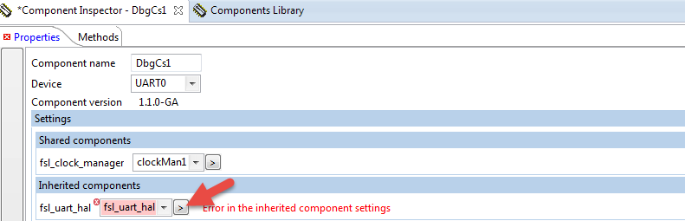
   9. Choose **UART0**, now you should have no errors.  
      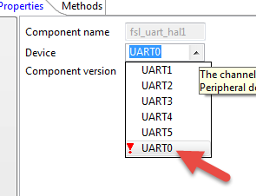
   10. Now, add some tasks. Processor Expert provides an MQX_KSDK_Task Component that will configure and generate the code framework for tasks.  
         
       Click Components Library.  
       image019.png  
         
         
         
         
         
         
         
       Under **Operating Systems**, double click **OS _Task** to add tasks.  
         
       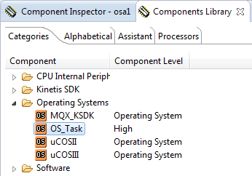
   11. Click on the task components to configure them. Be sure priority is set to 8.  
       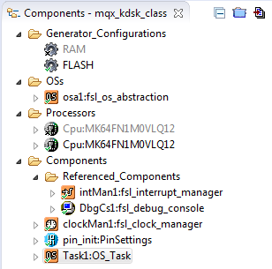  
         
       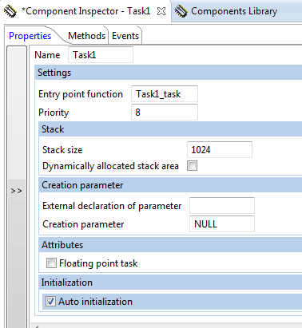
   12. Click the Generate Processor Expert Code button.

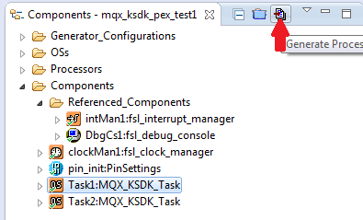

* 1. The code will generate (update the configuration files for the Kinetis SDK). Wait until that finishes.  
       
     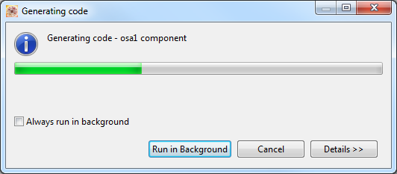

The MQX source code is here.

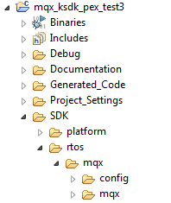  
  
  
The task code is here.  
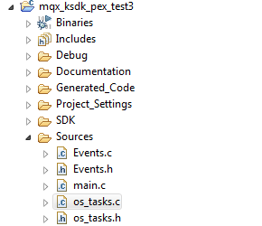

* 1. Write your tasks! You can write native MQX RTOS function calls as well as Kinetis SDK driver and HAL calls. Just make sure to include the appropriate header file for the MQX or KSDK feature you use and add to the paths if necessary.  
     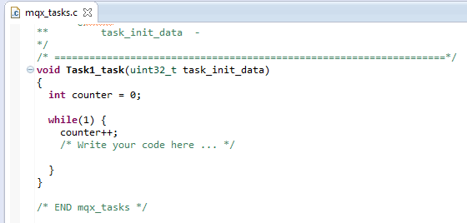
  2. Now click the build button.

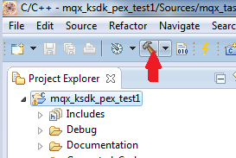

Your new project will compile and link into a file for downloading and debugging on the target  
